L.T Brookes Ltd - Product Specification Sheet 2017

Unsmoked rindless back bacon whole

Supplier code:
402,404,407

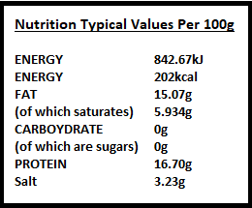
Ingredients declaration:
Pork 87%, water, salt, preservatives E250, E252,E300,E301.

Weight Variance:
WHOLE BACKS

Storage instructions:
Store 0-4c if frozen store below -18

Shelf life:

6 weeks shelf life from packing day. (Fresh)
1 year shelf life from packing day. (Frozen)

Batch coding:
Product code (+ week no. + dolav no. +slicing day)
All batches traceable from consignment delivery date.
Analytical/Microbiological Units:

All ingredients used in our products are used at recommended levels.
Microbiological specification conform to:
EC Regulation No.2073/2005 microbiological criteria for foodstuffs.
All suppliers are audited as part of our HACCP system

