L.T Brookes Ltd - Product Specification Sheet 2017

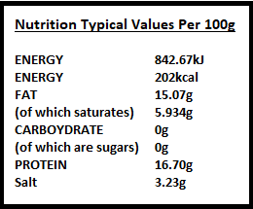
Naturally smoked rindless back bacon whole

Supplier code:
452,454,457,459

Ingredients declaration:
Pork 87%, water, salt, preservatives E250,E251, E252,E300,E301.

Weight Variance:
Whole between 6-9kg

Storage instructions:
Store 0-4c if frozen store below -18

Shelf life:

6 weeks shelf life from packing day. (Fresh)
1 year shelf life from packing day. (Frozen)

Batch coding:

Product code (+ week no. + delivery no.)
All batches traceable from consignment delivery date.

Analytical/Microbiological Units:
All ingredients used in our products are used at recommended levels.
Microbiological specification conform to:
EC Regulation No.2073/2005 microbiological criteria for foodstuffs.
All suppliers are audited as part of our HACCP system.

